* 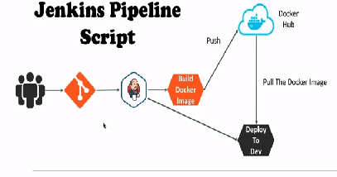**G****itHub repository is been cloned**

**First stage**

**node{**

**stage('SCM Checkout'){**

**git credentialsId: 'git-cred', url: 'https://github.com/vybhavkadam/my-app.git'**

**}**

* Maven clean

Second stage

stage('Mvn Package'){

sh 'mvn clean package'

}

* Build the docker image

Third stage

stage('Build Docker Image'){

sh 'docker build -t vybhavkadam/my-app:2.0.0 .'

}

* Push docker image to docker hub

Fourth stage

stage('Push Docker Image'){

withCredentials([string(credentialsId: 'docker-pwd', variable: 'dockerHubPwd')]) {

sh "docker login -u vybhavkadam -p ${dockerHubPwd}"

}

sh 'docker push vybhavkadam/my-app:2.0.0'

}

* Pulling the docker image to the production server

Fifth stage

stage('Run Container on prod Server'){

def dockerRun = 'docker run -p 8080:8080 -d --name my-app vybhavkadam/my-app:2.0.0'

sshagent(['prod-server']){

sh "ssh -o StrictHostKeyChecking=no ubuntu@172.31.33.253 ${dockerRun}"

}

}

The failure is to pull the docker image from the docker hub to production server